* New workspace named Module3_Assessment created

* New collection named GoRest created.

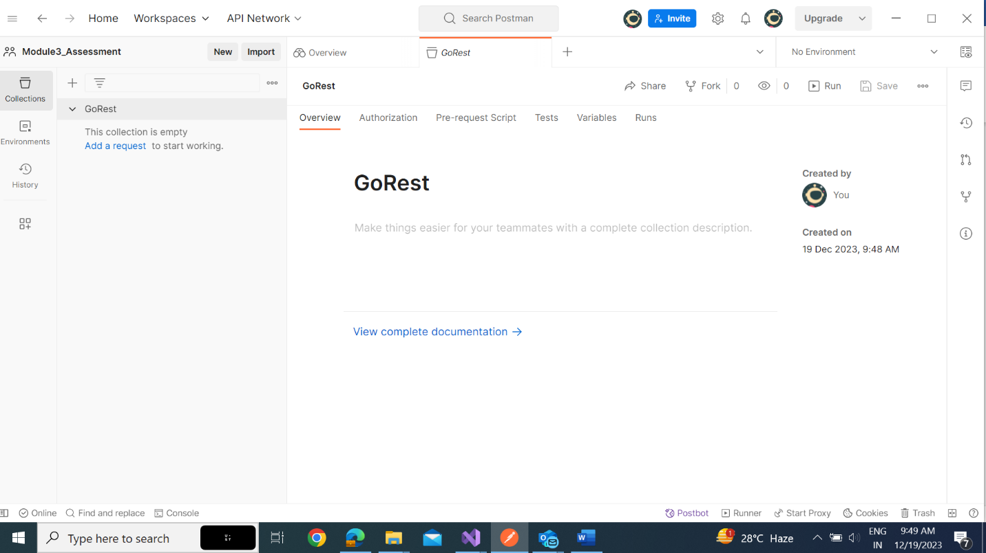

* New Environment named GoRestEnv Created.

**Get**

* Get all user request with response

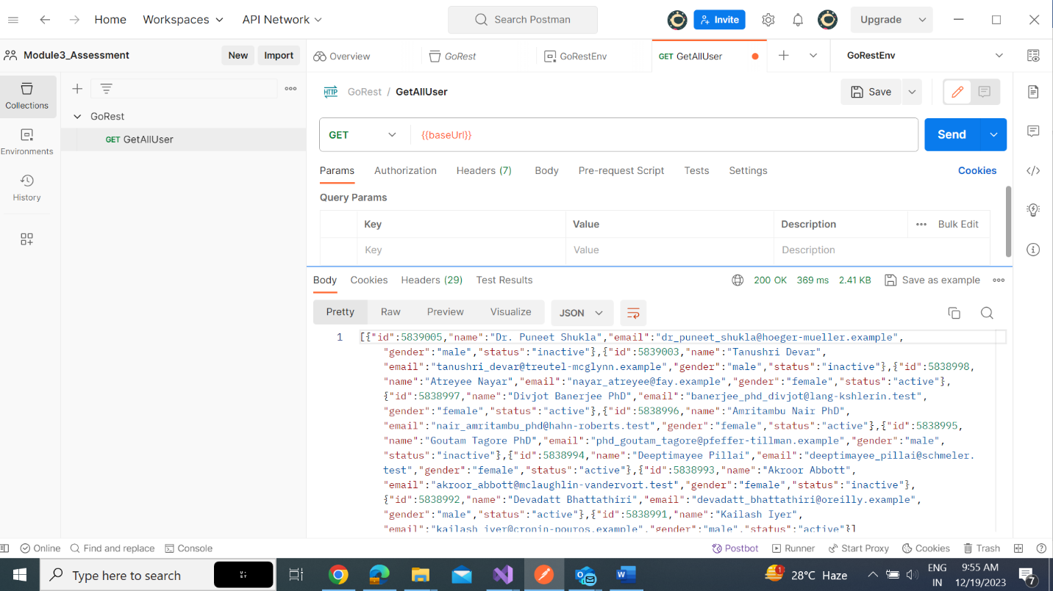

* Body matches with string “Dr.Puneet Shukla” Test and result

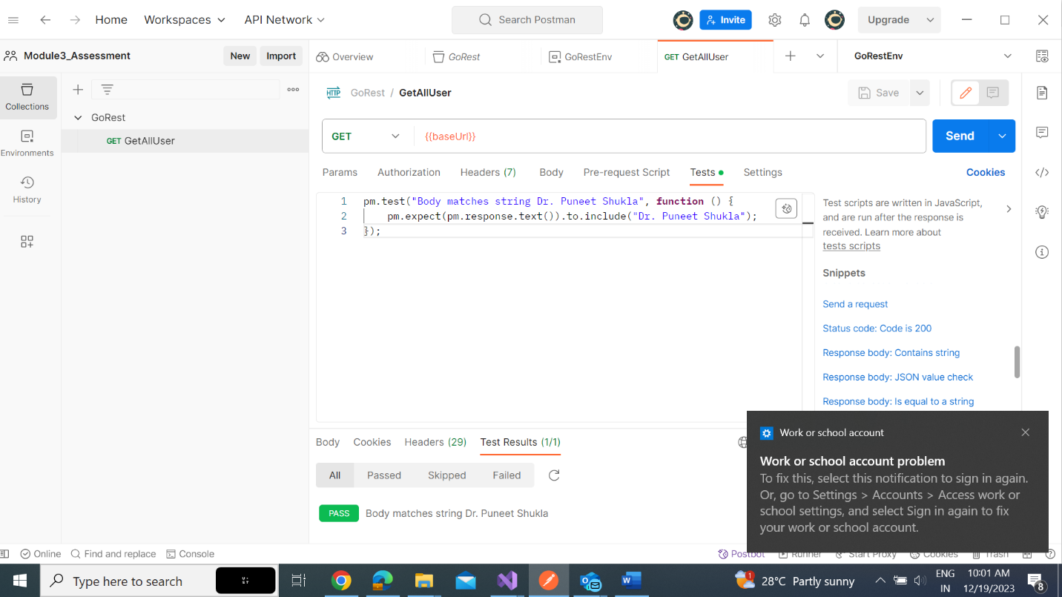

**Post**

* New user created

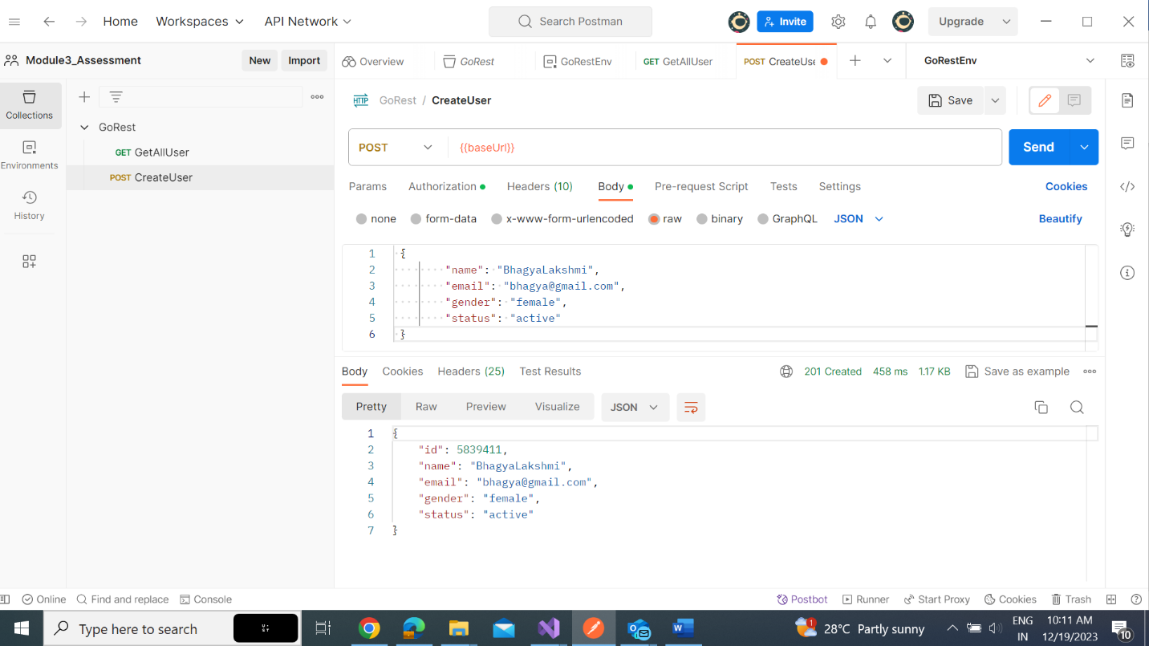

* Successful post request test and result.

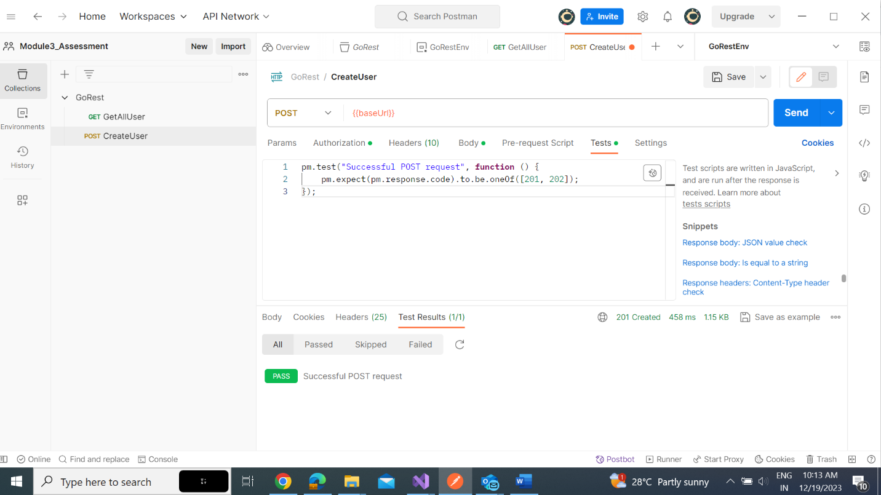

**PUT**

* Creating PUT Request and response

* Gender check Test and Result

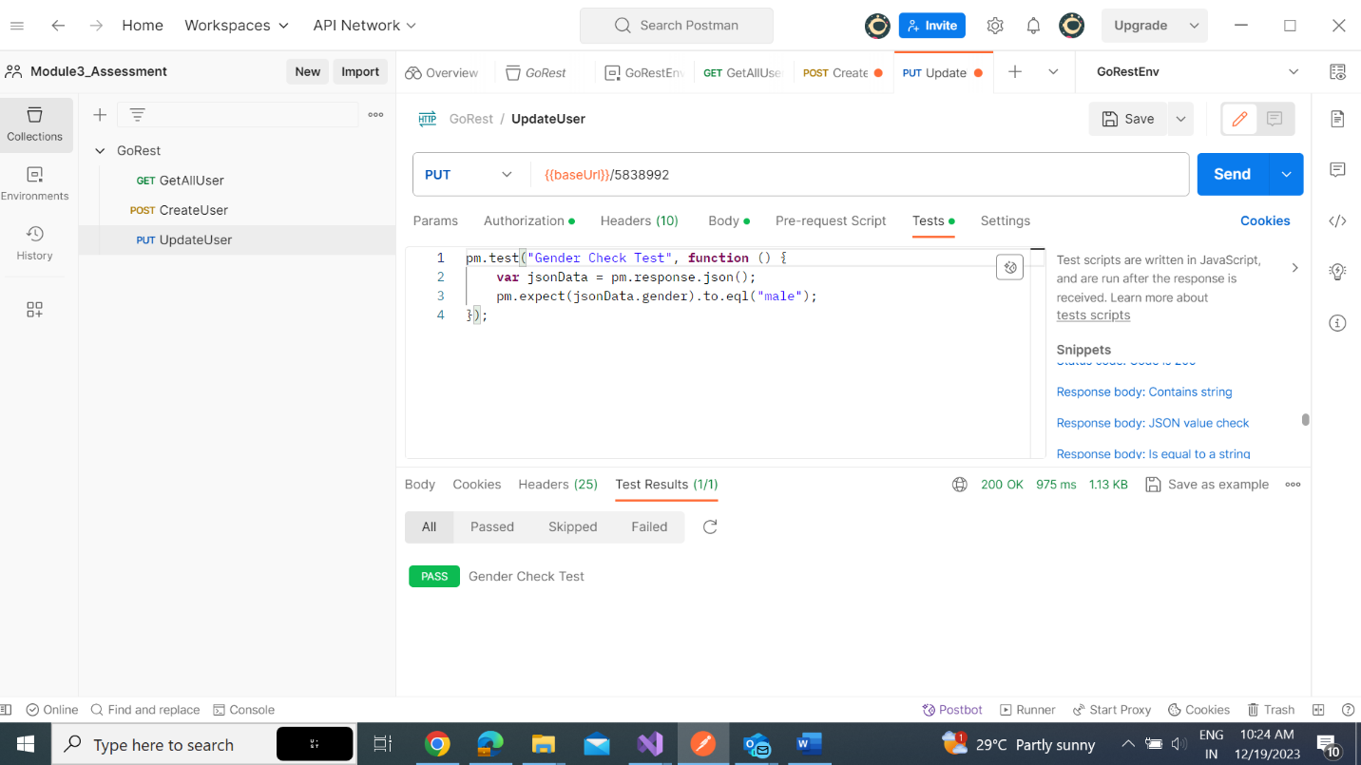

**DELETE**

* Delete Request and Response

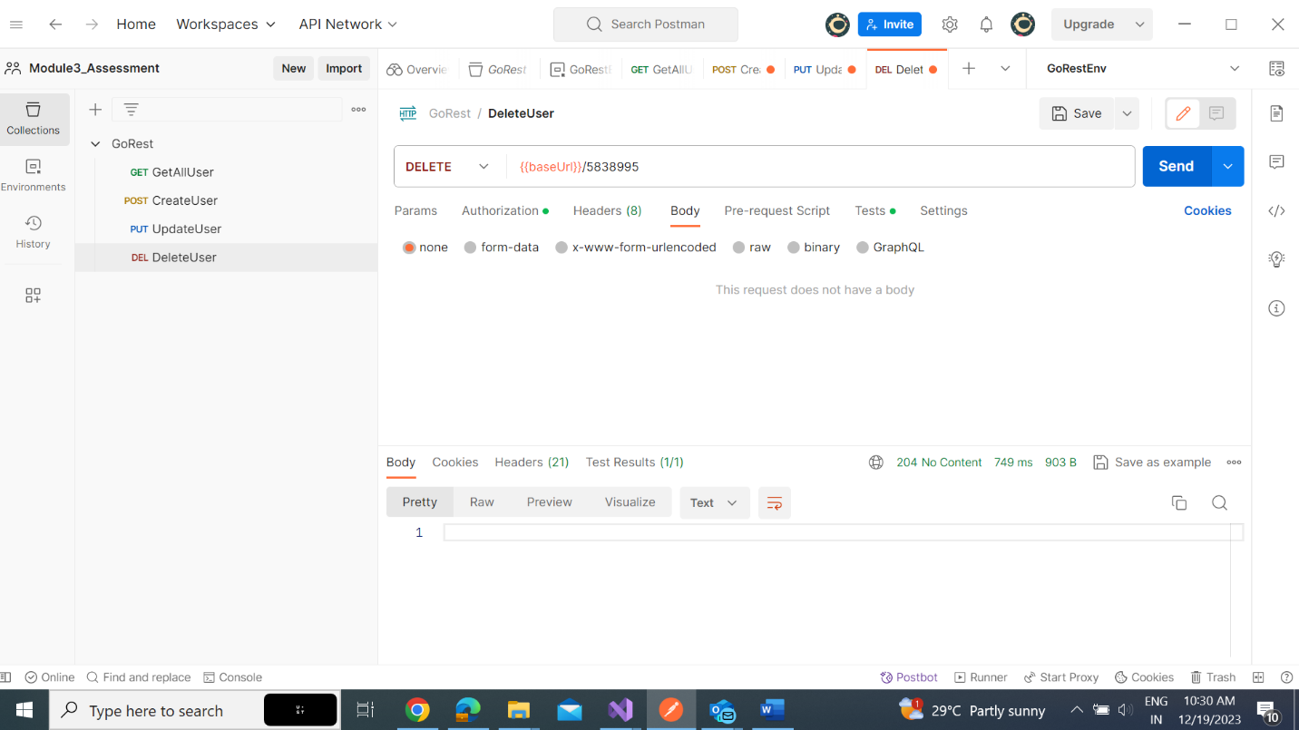

* Response Time Test and Result

**Get**

* Get single user request and response

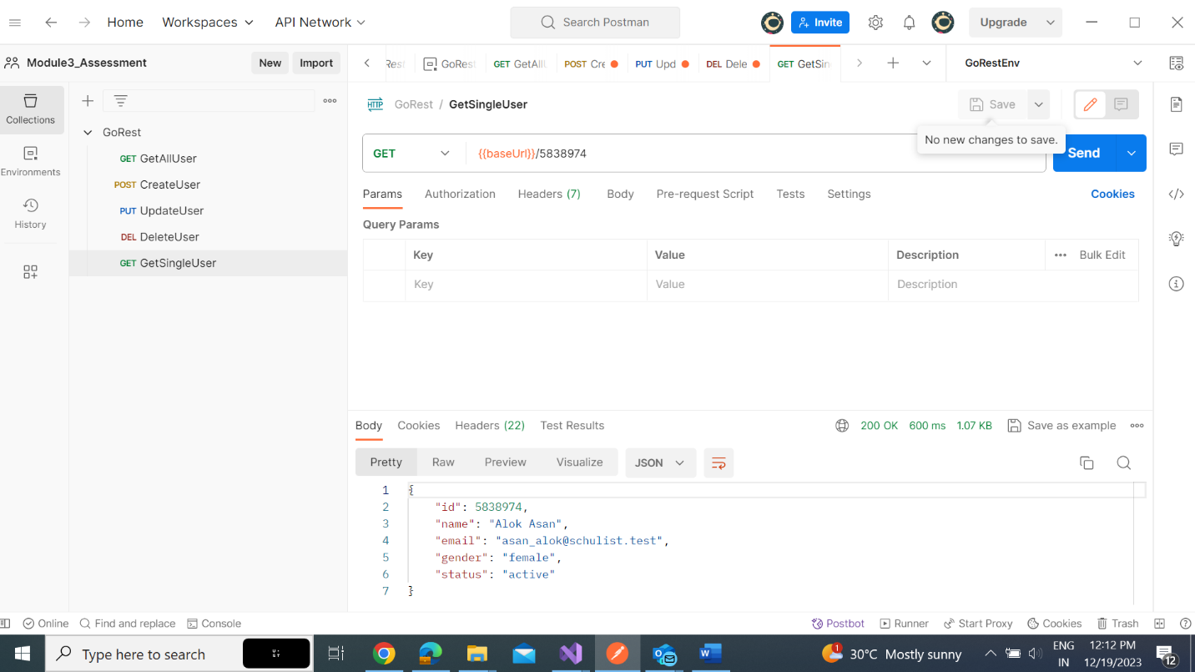

* Email id checking Test and response

